Auriana Anderson
Jeremiah Lowhorn
DSE6210
February 16, 2025

Lab/Assignment 5
- After the data has been loaded select the sample_airbnb dataset and run the following query.
  - {bedrooms:{$gte:10}}
  - How many AirBNBs are there in the results?
    - There were 4 AirBnB’s in the results
  - What is the ID of the AirBNB with the most bedrooms?
    - The ID is : 20701559
  - Submit a screen shot of the document with the most bedrooms.
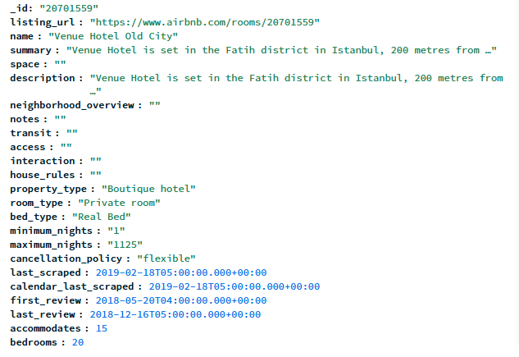

- Click Connect, then select Drivers
  - Select Python
  - Follow the instructions to install pymongo in your python environment
  - Use the sample code and populate the connection string variable with the string provided in the Mongo Connect/Drivers template
    - lab5_q6code-2.pyDownload lab5_q6code-2.py
  - Execute the code from the lab_q6code.py file
    - What type of cuisine is the restaurant?
      - The type of cuisine is Delicatessen
    - What is the object type? (execute the last line of code)
      - <class 'dict'> is the object type, so it’s a dictionary.
    - Take a screen shot of the printed nordic object from console
*I wasn’t sure how to fit the entire doc from console so I just screenshotted what I could.

